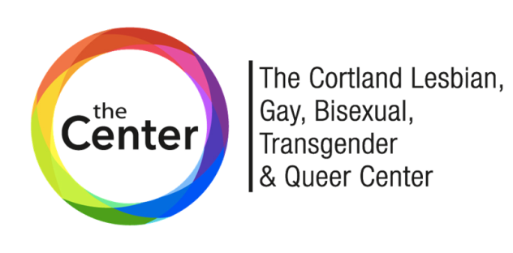
A Division of Family Counseling Services
165 Main Street Suite A, Cortland, NY 13045
(607) 756-8970 ext 253
mdoughty@familycs.org

Volunteer/Intern Application
Name: Pronouns:
Mailing Address:
Phone Number: Other:
Email address:
Optional Info:
In Case of Emergency Notify --Name:
Address: Phone Number:
List any necessary accommodations (health, allergies, ability):
Occupation: Work Phone Number:

Educational/Training Background
(Any experiences, training, or education that could help as a volunteer)
School/Training Date Attended Major Degrees Received

Special Training _______________________________________________________________________________________
How did you learn of the Cortland LGBTQ Center?_______________________________________

If you are in a Service Learning Class or you are required to volunteer for any other reason, please complete below:
Course __________________________Instructor’s name______________________________________________________
Other organization_______________________________________________________Hours required_________________

Why do you wish to be involved with us? __________________________________________________________
____________________________________________________________________________________________________
____________________________________________________________________________________________________
Hobbies/ Special Interests _______________________________________________________________________________
____________________________________________________________________________________________________ Do you have a reliable way of getting to work? _______ Yes _______ No
May be asked to help load/unload supplies to and from events.

Have you been convicted of a crime? __________ Yes ___________ No
If yes, does not automatically exclude from position.
If yes, please explain ___________________________________________________________________________________
Have you been the subject of an indicated child abuse report? ___________ Yes __________ No
If yes, please explain ___________________________________________________________________________________
____________________________________________________________________________________________________
References ***Please note all information must be complete for your application to be processed.

Name Relationship Phone # Email
1.
2.
3.
With the undersigned, hereby give my permission for Cortland Prevention Resources to verify the information I have given.

___________________________________________ _________________________________
Applicant’s Signature Date
8/2022

